**Tutorial**

In this part, we will provide a hand-by-hand tutorial of how to use the Zetwork platform.

1. **Set up**

To set up, please follow the following steps:

a) Download the project from github or other code repository where the code project is.

b) In terminal, cd into the backend project folder and find the folder called “dbDump”. To import the database data into database, please first log into the mysql shell and use the “testdb” database by this command “use testdb;” and then use the command “source databasedump.sql” to import the original data.

c) In terminal, cd into the frontend folder and run the command:

./activator run

d) In terminal, cd into the backend folder and run the command:

./activator "run 9034"

e) The Database connection information is as follows:

user: root

password: set in your own computer as “root”

f) Login URL: localhost:9000/login?

**(2) Sign Up**

To sign up, just click the sign up page and fill in the required information, then you click the submit button, you will get a sign up success page, and your registration has been success.

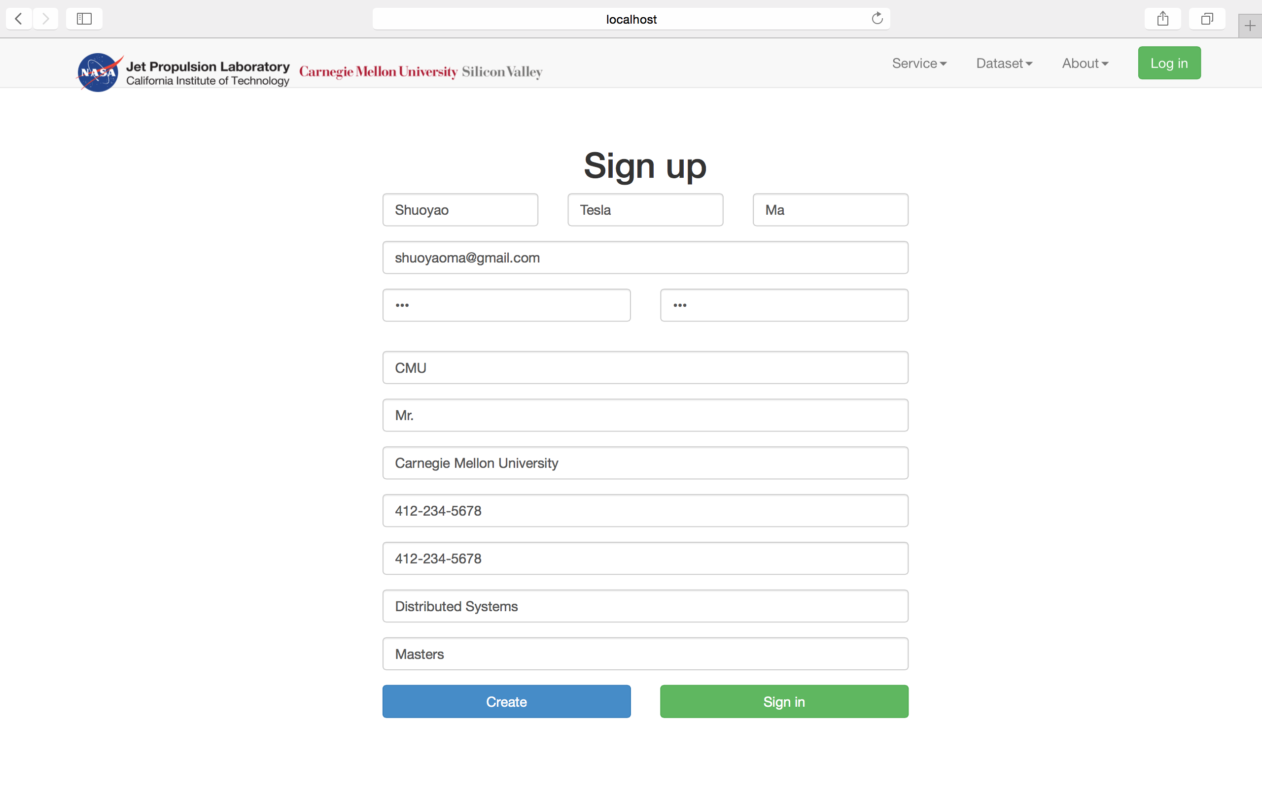

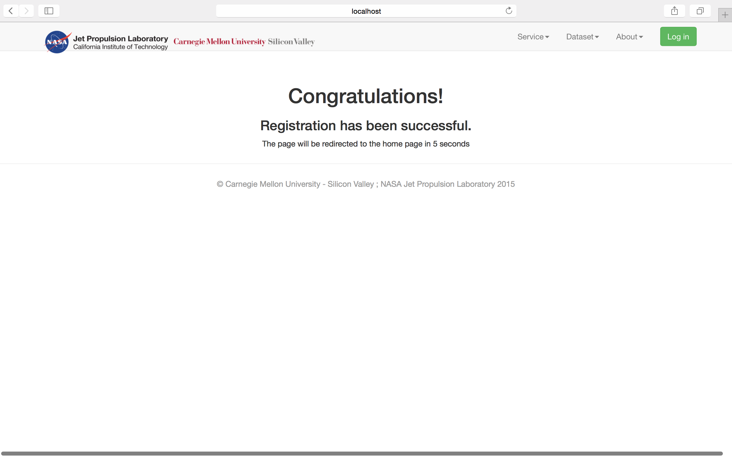

**(3) Sign In**

After you have signed up, you can use your email address and password to sign in:

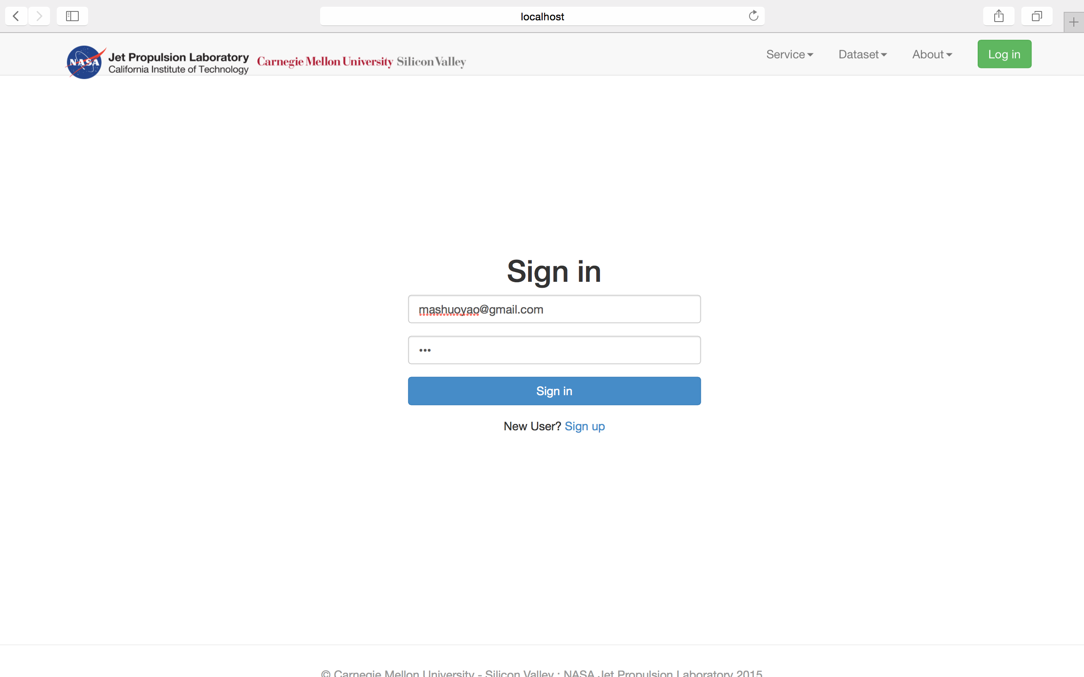

**(4) Main Page**

After you have signed in, you will see your main page

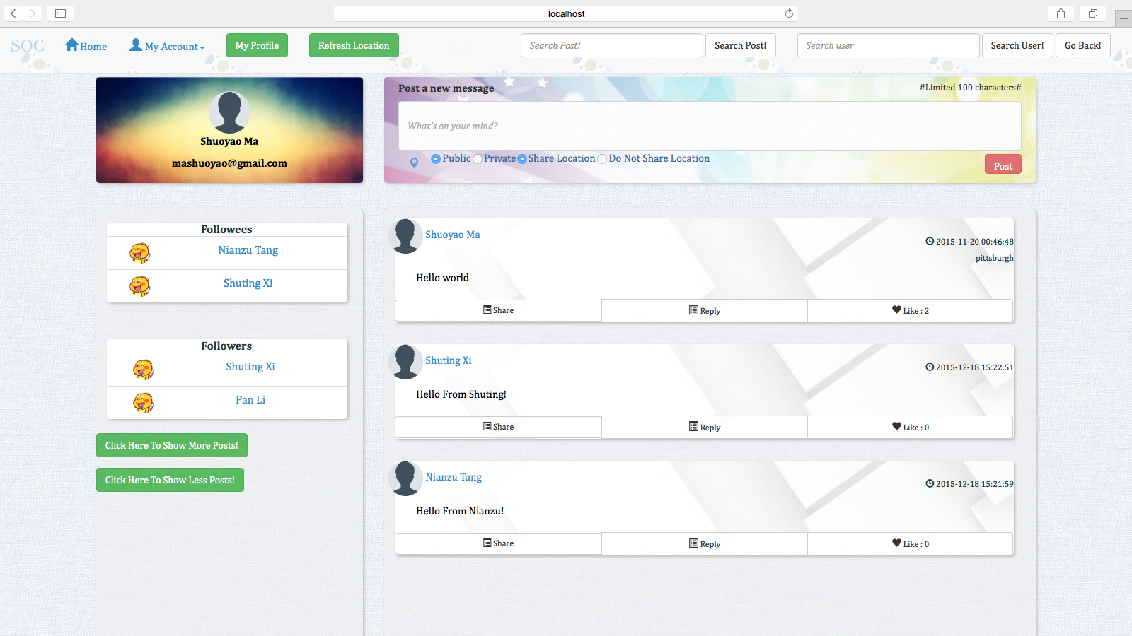

**(5) Home Page**

When you click a user name or you click the my profile button, you will see the home page of a user:

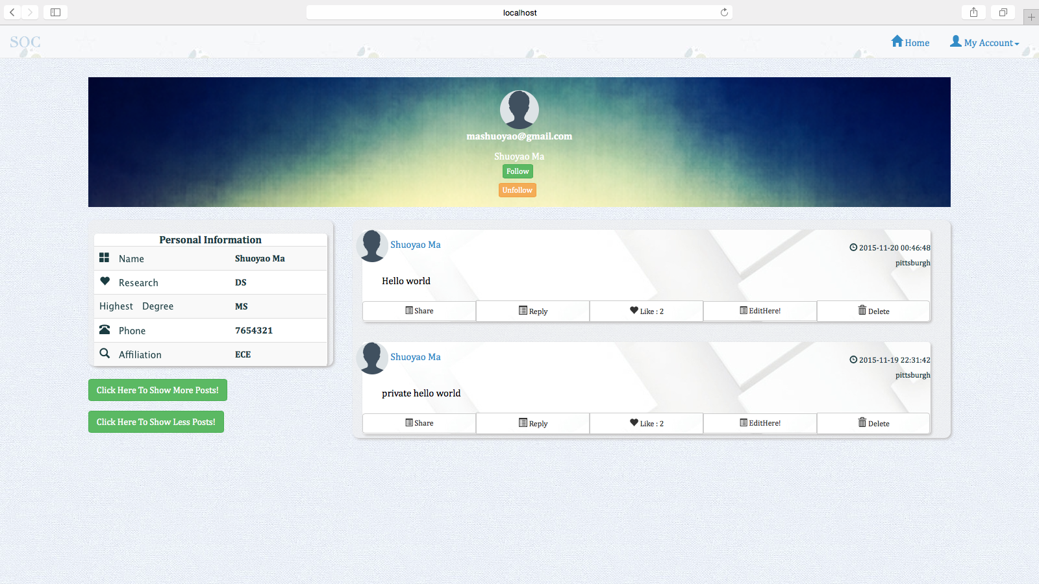

**(6) Add Post**

There are many options to add post.

Post added in private will not be seen in the main page, but can be seen in the user’s own home page. In the following screen shots, the post “Hello from Shuoyao - Private” is added, but can be only seen in Shuoyao’s home page when Shuoyao logs in.

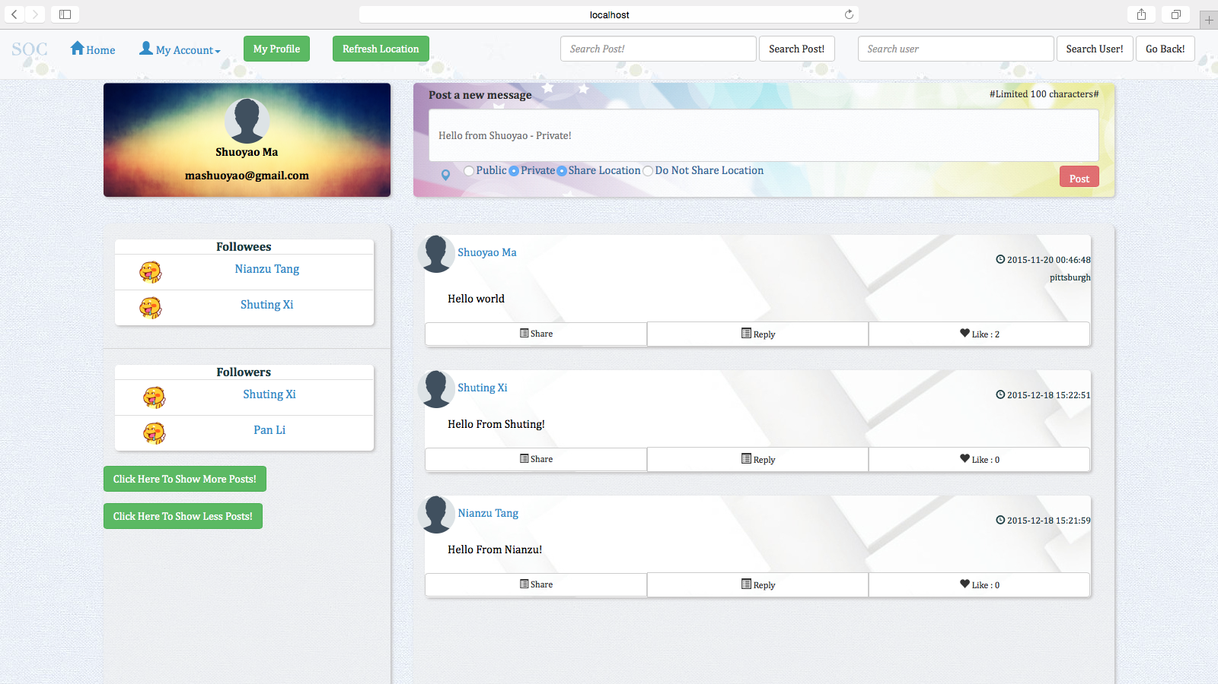

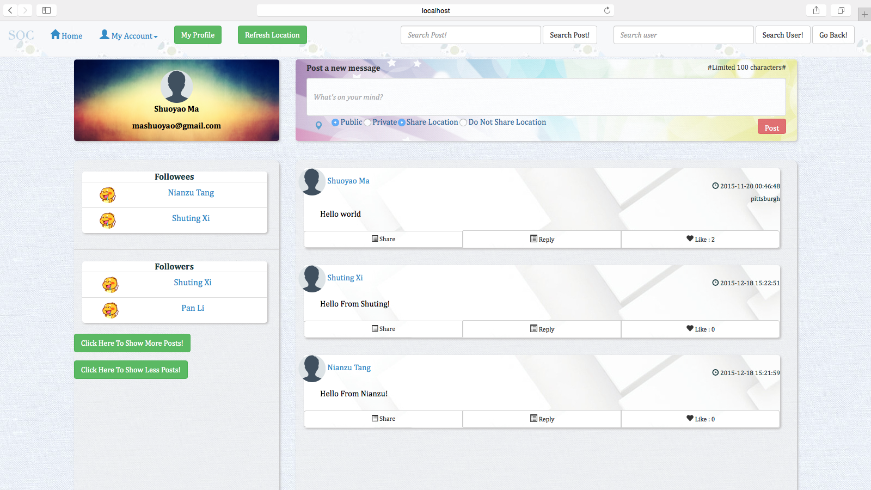

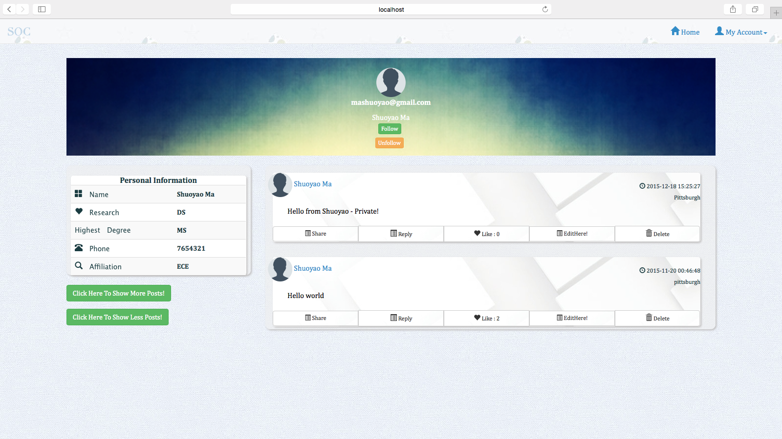

Post Added in public will be seen by others in the main page. The Post “Hello World” Posted by Shuoyao has been seen in the main page and also in the home page.

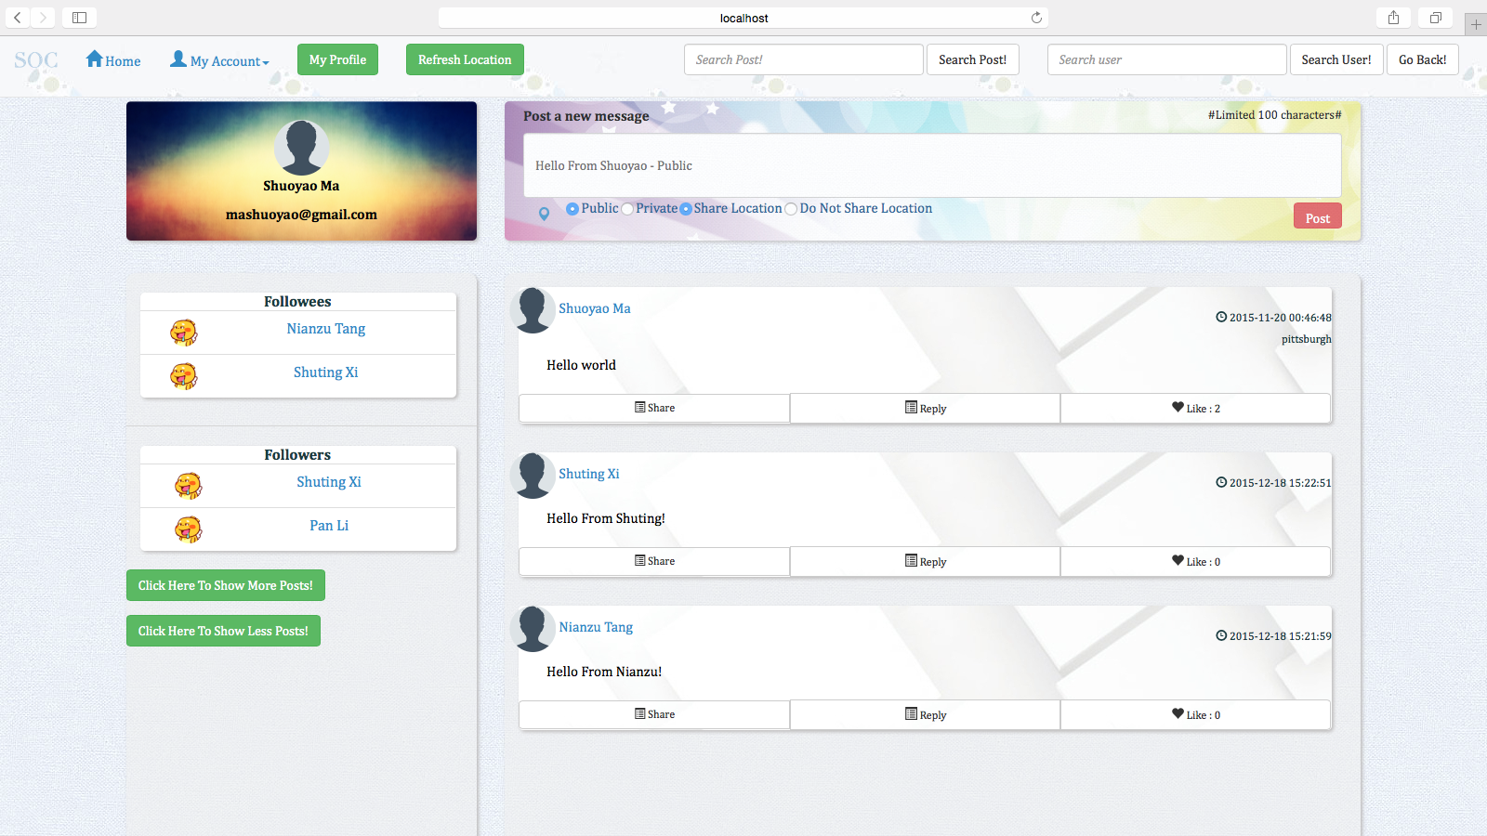

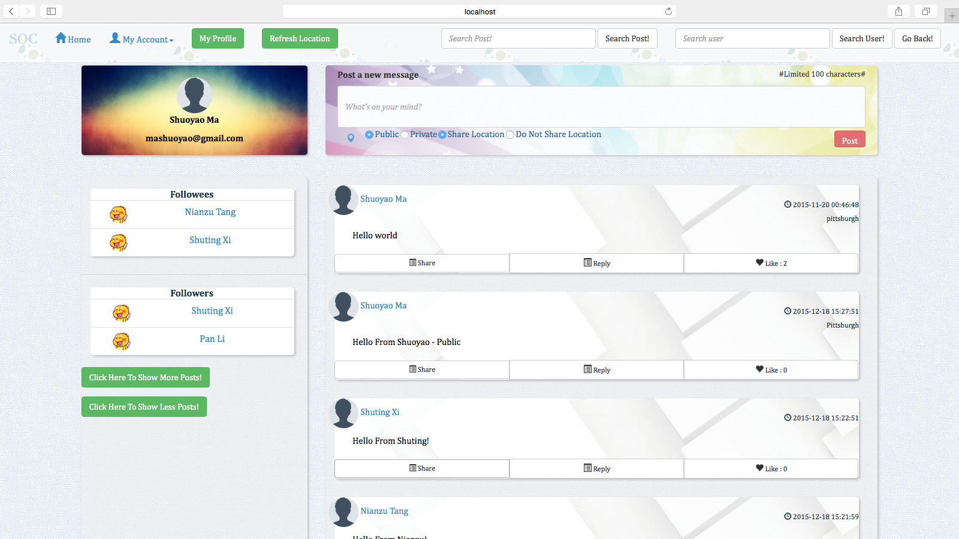

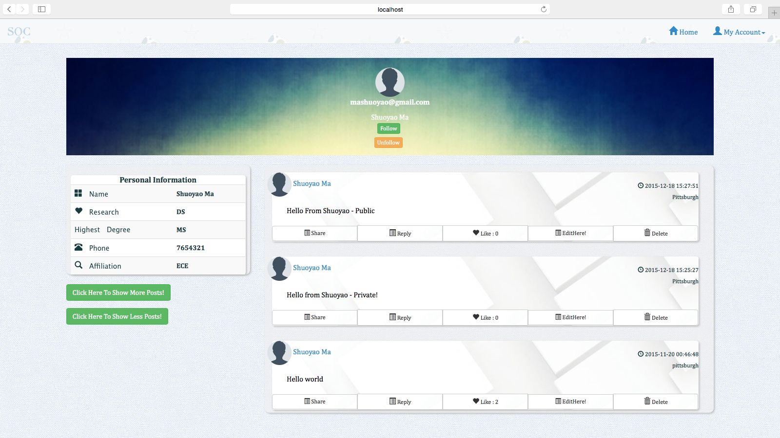

There is also an option that you can choose to add post but do not share your location, the post without the location is posted when the user chose the “Do Not Share Location” option when posting:

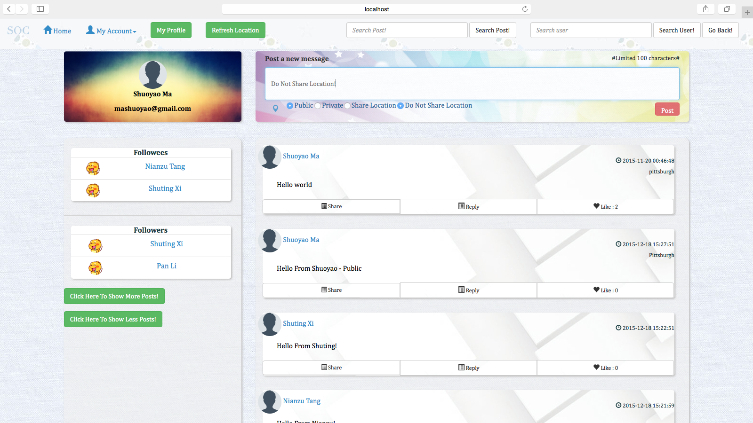

**(7) Delete Post**

The user can delete his/her post in his/her own home page, you can see, the post “Hello World” Has been deleted:

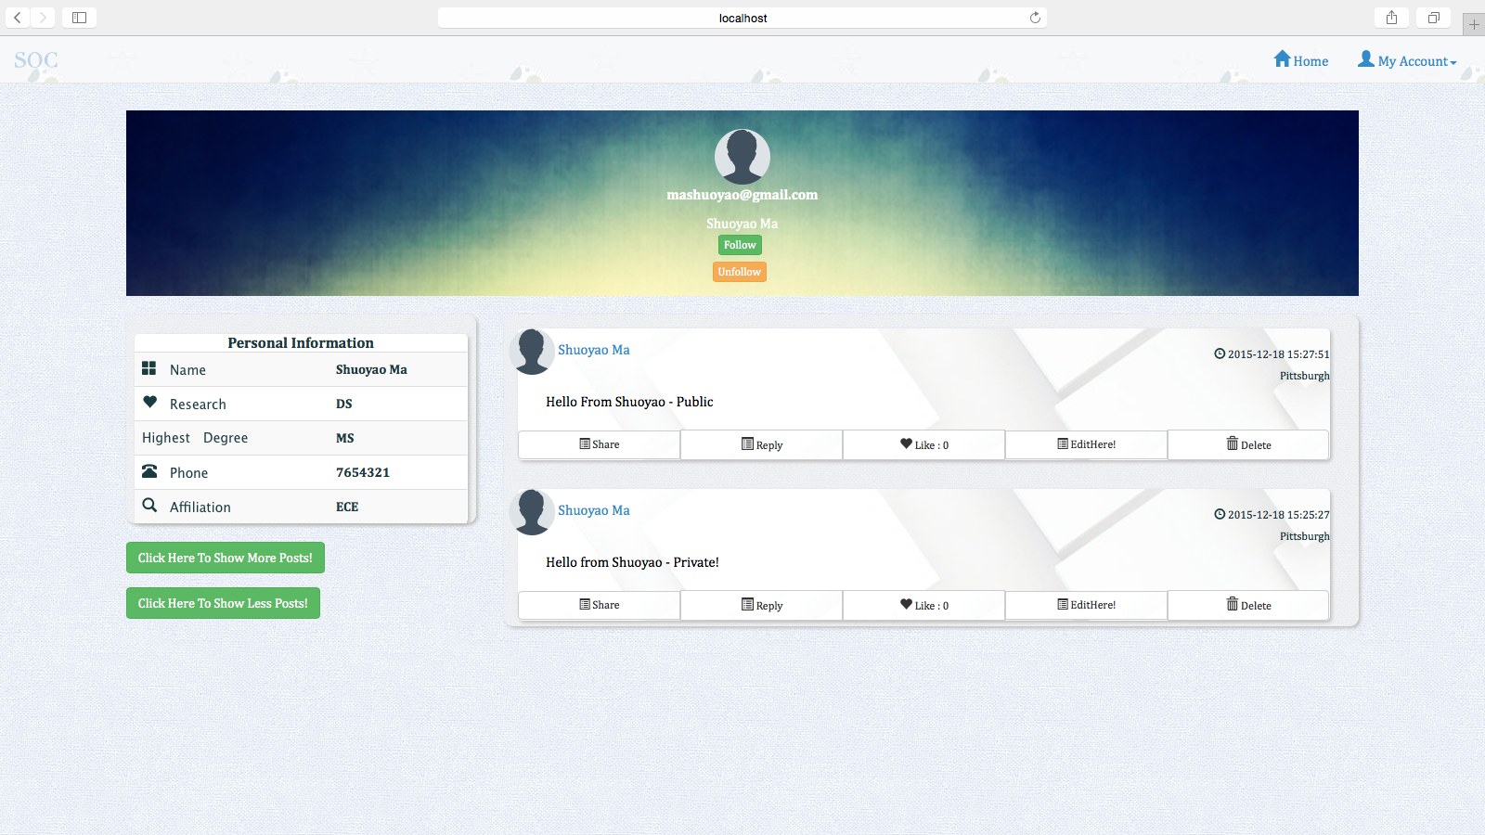

**(8) Like Post**

A user can like a post, you can see, the post “Hello From Shuoyao - Public” has been liked, it has 1 like:

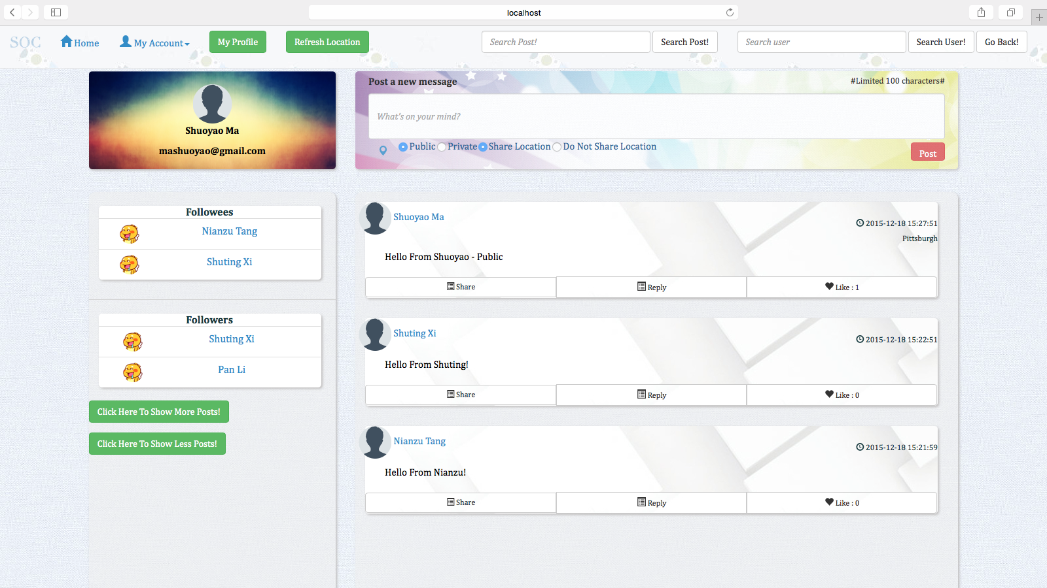

**(9) Comment Post**

A user can comment the post of other users, you can see, Shuoyao has commented Shuting’s Post:

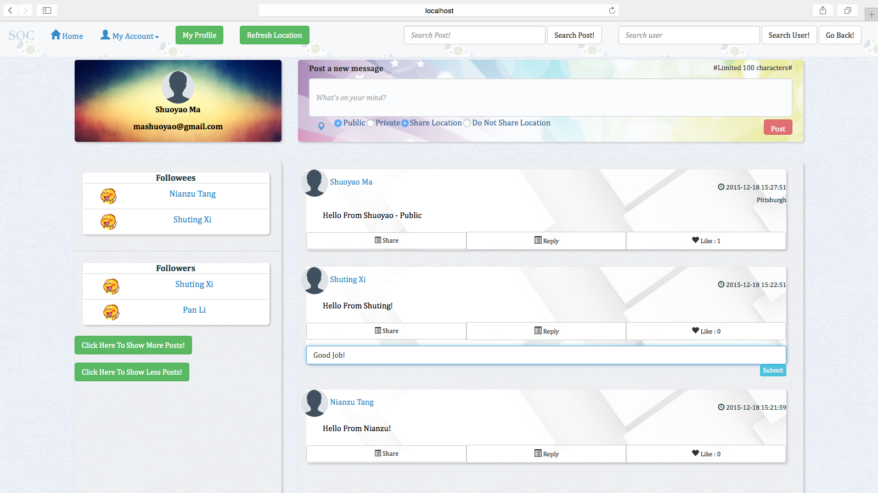

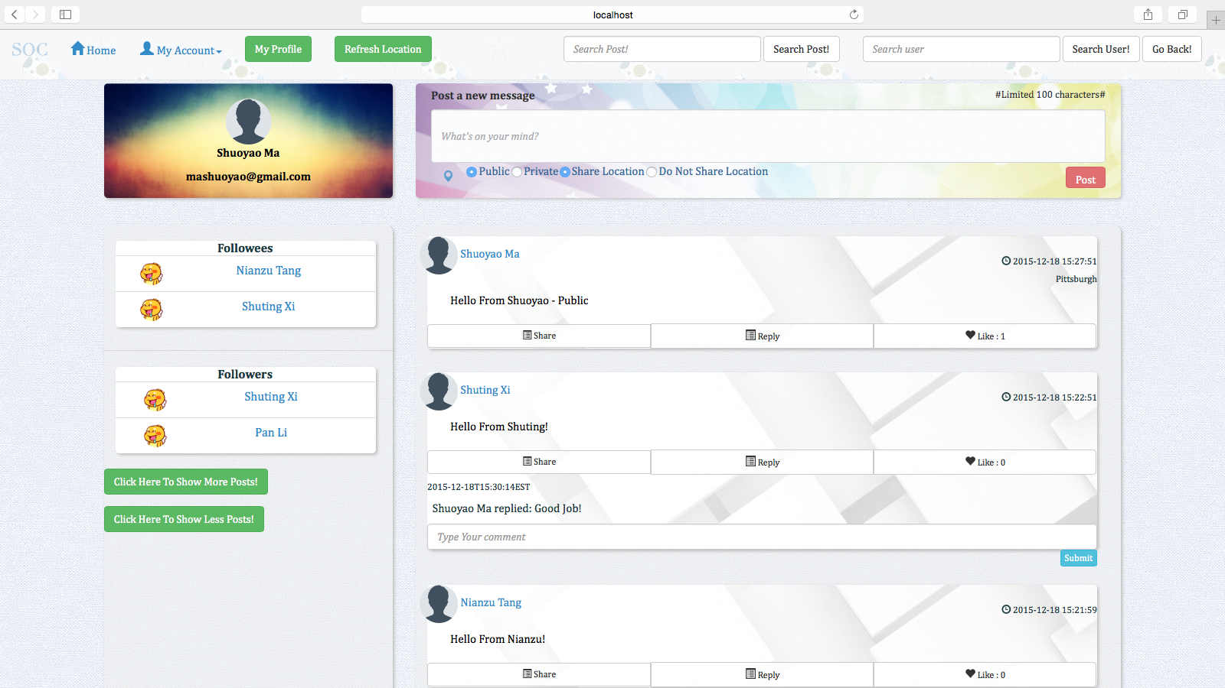

**(10) Share Post**

A user can share the post of another user, you can see, Shuoyao has shared the post of Nianzu:

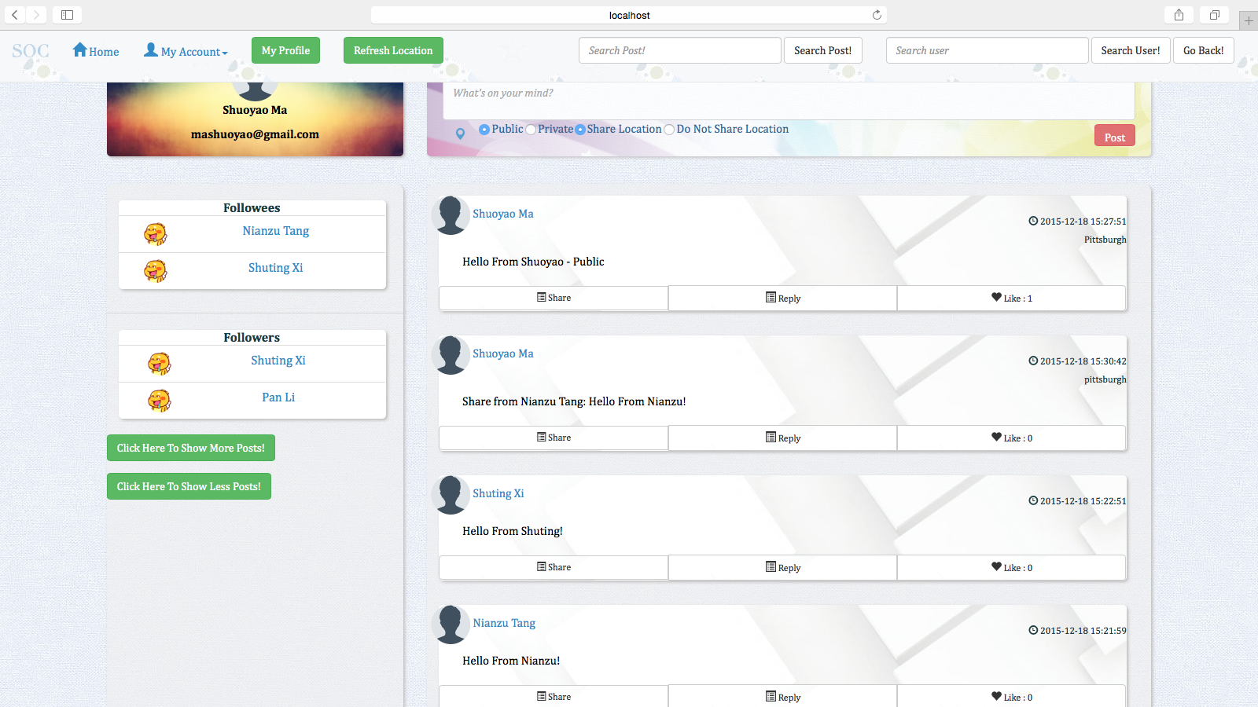

**(11) Edit Post**

A user can edit post in his/her own home page:

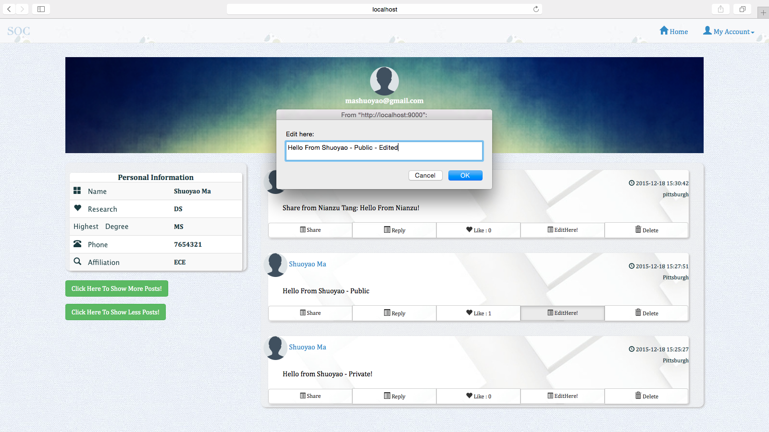

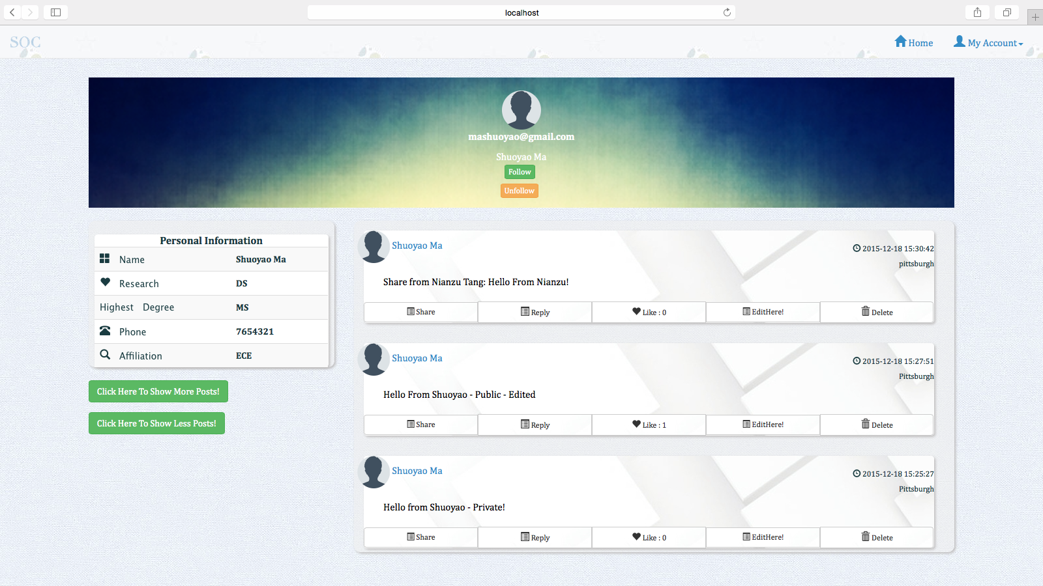

**(12) Search Post**

User can search post by key word:

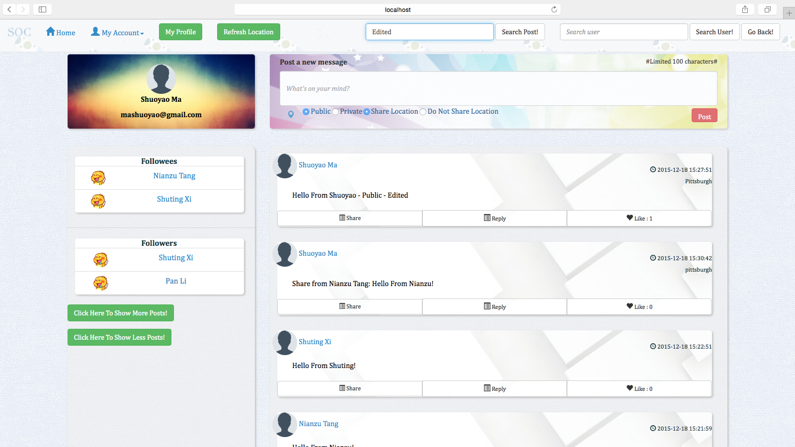

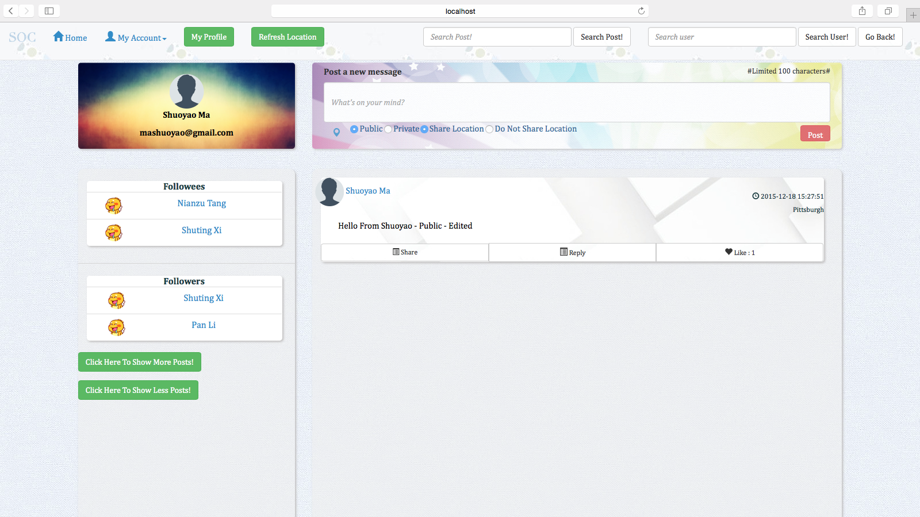

**(13) Search User**

User can search other users:

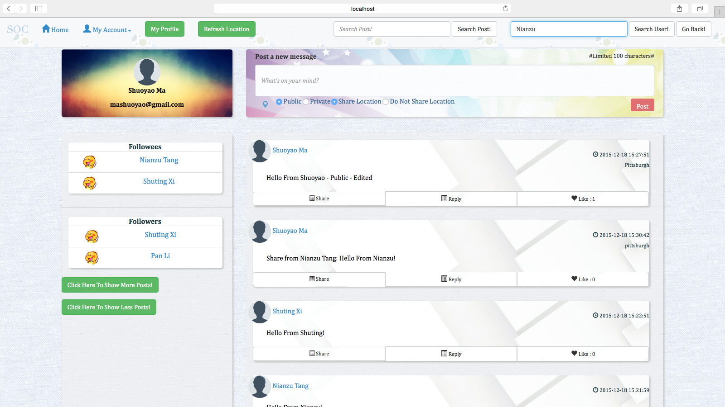

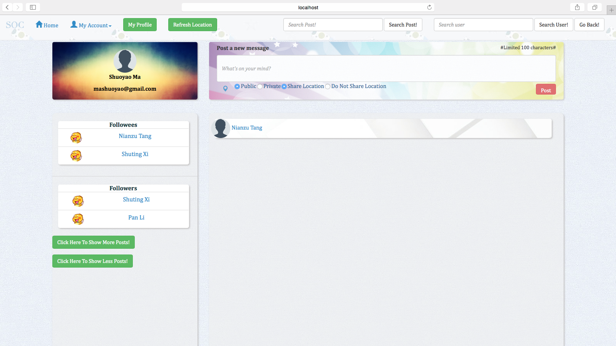

**(14) Follow**

A user can follow another user by entering the other user, and click follow in his/her home page, after that, the follower and the followee will be reflected in the main page of both users, you can see, Shuoyao has followed Nianzu:

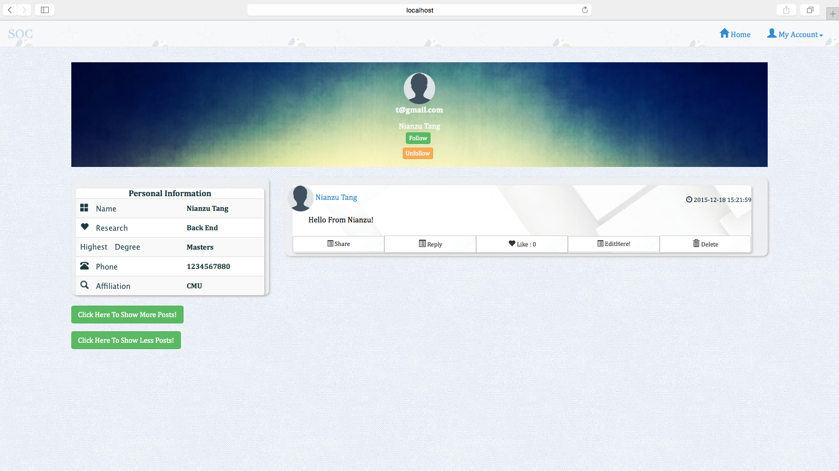

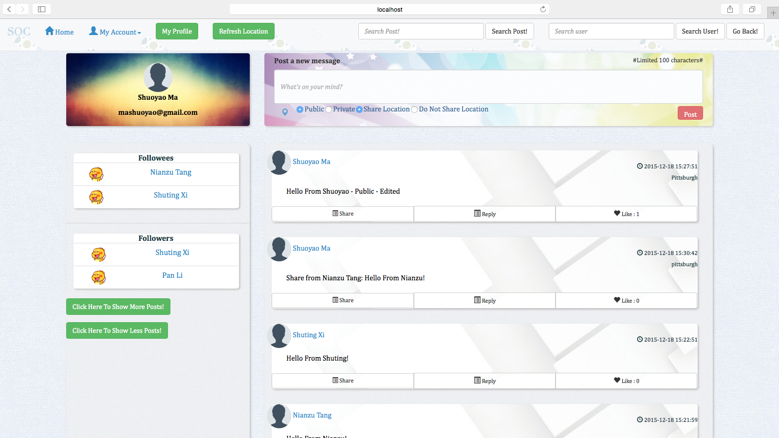

**(15) Unfollow**

The user can also unfollow another user by entering his/her homepage and click the unfollow button, you can see, Shuoyao has unfollowed Nianzu:

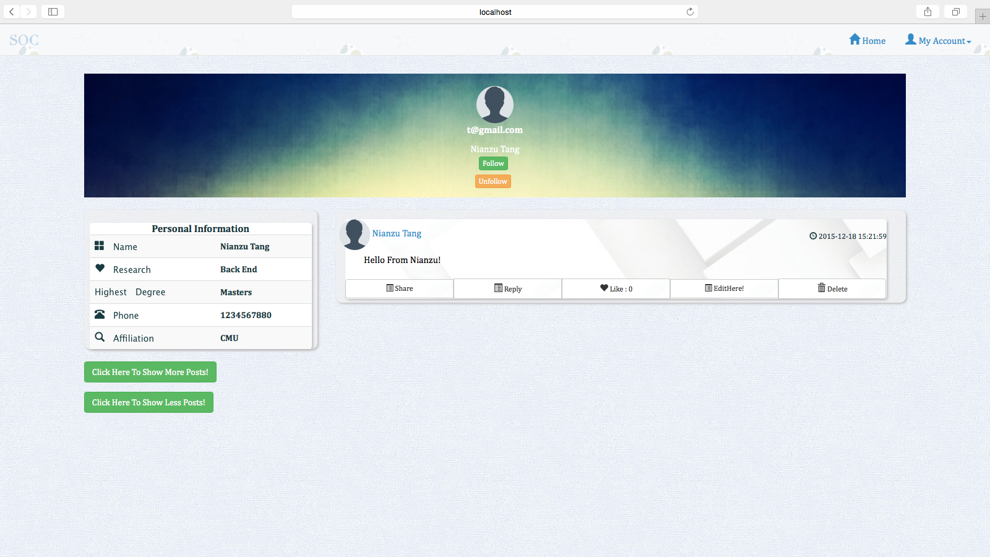

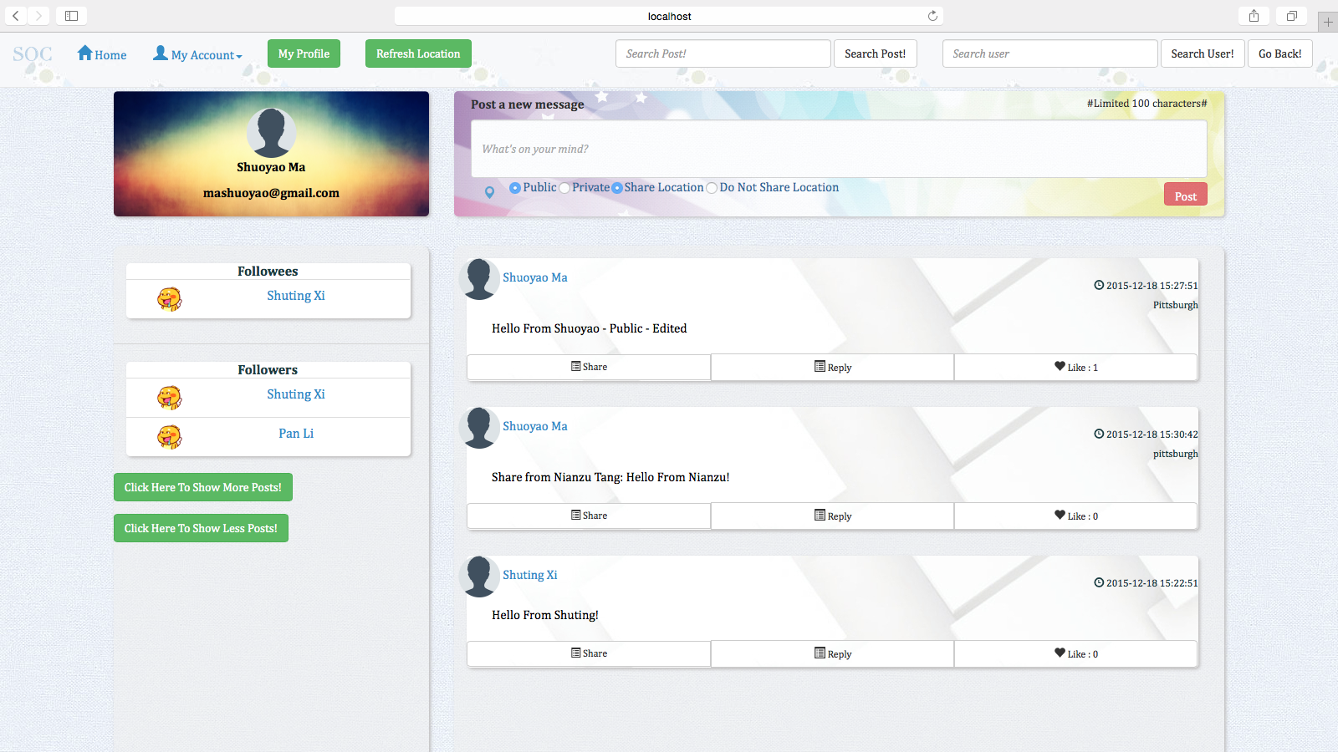

**(16) Edit User Profile**

The user can edit the profile of himself/herself:

